To change the “ACCOUNT CREATED BY” field, user should click on the PROFILE NAME
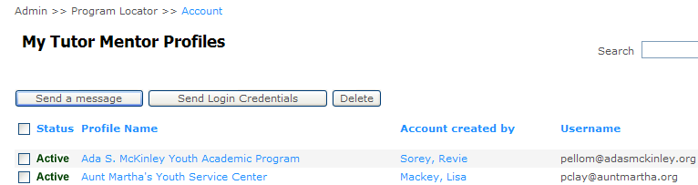

In the “Tutor Mentor Program Survey” page, add new text box for “SURVEY CREATED BY”. This will be visible for “NETWORK ADMIN” or “NETWORK STAFF” only -

